

AN E-NEWSLETTER CONNECTING ORGANIZATIONS THAT CARE
September 2003
Volume 03-17

WELCOME BACK TO PAIN ADVOCACY COMMUNITY

We would like to feature upcoming events related to hearings, meetings or debates on pending or contemplated regulations or legislation, so help us help you. If you would like us to invite others to participate in or collaborate on your upcoming projects, make others aware of resources that may be helpful to their constituents, or acknowledge a job well done, please e-mail us at patientadvocacy@pharma.com.

Feel free to share this newsletter with other concerned healthcare professionals or organizations.

TOPICS FOR September 2003:

On the Horizon
Pain Advocacy Community E-Newsletter Available on Website

In the Spotlight
Research!America Survey on Pain
Noted Researcher, Peter Hart, Discusses the Findings and the
Public Health Implications From National Pain Survey

Legislative Update
Oregon Passes Pain Management Education Legislation

Chatter
New Educational Tool Announced to Fight “Epidemic” of Untreated Pain

Bucks Box
The Prostate Net Provides Incentives for Consumers and Barbers
  - Click here if you wish to be removed from the E-newsletter list

Links provided in this newsletter, except for patientadvocacy@pharma.com and www.partnersagainstpain.com, are sites not associated, affiliated or controlled by Purdue andPurdue takes no responsibility for the content of those sites.

ONTHEHORIZON

Pain Advocacy Community E-Newsletters Available on Partners Against Pain Website


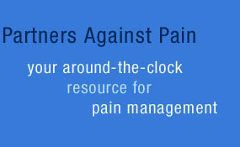

Log on to www.partnersagainstpain.com and go to Advocacy.

In the coming months, the Advocacy Section will feature advocacy tools, interviews and articles of interest to organizations, healthcare professionals and caregivers.

INTHESPOTLIGHT

Major Pain Survey Shows Chronic Pain Is Pervasive

On September 4, 2003, Research!America, a not-for-profit, public education and advocacy alliance group, presented results from a national survey on pain entitled “Americans Talk About Pain.” According to the news release, the survey results show that more than half of all Americans (57 percent) have suffered chronic or recurrent pain in the past year. Surprisingly, younger people (18–34) were as likely as older Americans to be in pain. The impact of pain is experienced by three out of every four surveyed (76 percent), who have either suffered from chronic or recurrent pain themselves or have a close family member or friend has suffered.

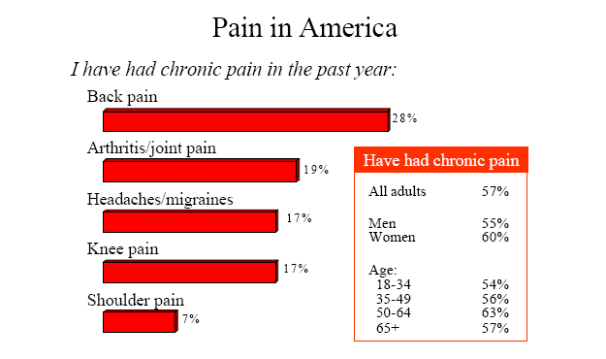

Chart from Research!America “Americans in Pain” Survey
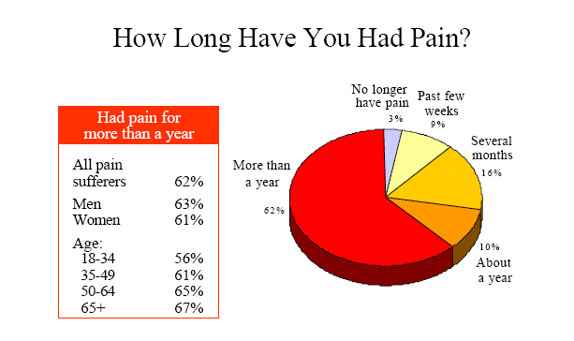

Chart from Research!America “Americans in Pain” Survey

INTHESPOTLIGHT Continued

Other key findings:

- Of the 57 percent who suffered from chronic or recurrent pain in the past year, 62 percent have been in pain for more than a year and 40 percent report being in pain all the time.

- Approximately, four out of 10 (39 percent) chronic pain sufferers have had to make major adjustments in their lives, including taking disability leave from work; changing jobs; requiring help with daily activities such as bathing, dressing and eating; or moving into housing that is easier to manage.

- 67 percent of those surveyed believe a cure for chronic pain is at least 10 years away.

- 57 percent are willing to pay one dollar more each week to increase federal funding for pain research.

- 42 percent say American culture views pain as more of a weakness than a misfortune.

“This survey should serve as a wake-up call to all Americans—including our elected leaders—that chronic pain is a problem of epidemic proportions in our country,” said Mary Woolley, president of Research!America.

James Campbell, MD, chair of the American Pain Foundation, agrees that the survey reveals a widespread misunderstanding of both the prevalence and the debilitating effects of pain in our society. “These poll results show that pain is a pandemic health problem,” Campbell said. "In a society where we can do heart transplants and treat AIDS, severe pain should no longer be acceptable. Perhaps most importantly, the poll demonstrates that pain research needs more emphasis and funding so that we can improve the quality of life for countless Americans."

Campbell is also professor of neurosurgery and director of the Blauststein Pain Treatment Center at Johns Hopkins University Medical Center.

The nationwide random telephone survey was conducted for Research!America among 1,004 adults July 15–19, 2003, by Peter D. Hart Research Associates. The data’s margin of error is ±3.1 percentage points among all adults at the 95 percent confidence level. For additional survey results and/or background and methodology information, contact Research!America at 703-739-2577, ext. 43, or visit www.researchamerica.org.

Noted Researcher, Peter Hart, Discusses Findings and the Public Health Implications from National Pain Survey

The “Americans Talk About Pain” survey was conducted for Research!America by Peter D. Hart Research Associates. Hart Research Associates is one of the leading survey research firms in the United States, conducting public opinion work for NBC and the Wall Street Journal, as well as major corporations, including AT&T, General Motors, Coca Cola, and American Airlines.

INTHESPOTLIGHT Continued

Since 1971 Hart Research has conducted more than 5,000 public opinion surveys that have included interviews among more than 2.5 million individuals.

Below, Peter Hart comments on the “American Talk About Pain” survey findings.

When you were asked to do the survey on pain did you come in with any preconceived notions?

The interesting thing to me is that with each survey you try to figure out what the dynamic is and what is happening there. And so, when I came into the area of pain, I thought we were looking at a nice little specialized survey that had to do with people who faced pain and like everything else it would have its small little constituency.

What shocked me about this was that we ended up with pain as a universal problem facing the people in the United States. 57% of all Americans tell us that they have had chronic pain or recurrent pain within the last year. That is an astonishing number of people.

And when you add to that, another 20% who care for or are directly involved with people who have chronic pain, you recognize how pervasive it is. To me, that was one of the major shocks out of this survey—I was not prepared for, nor did I suspect, how pervasive it was.

I thought it was an important problem to look at—but a limited problem. Instead, what I found out was that it’s both a major problem and it is indeed a universal problem.

What do you think healthcare professionals should come away with from this survey?

I think there are a lot of things healthcare professionals need to come away with out of this survey. First and foremost, is the amount of adjustment pain has caused in people’s lives. And when I talk about adjustment, these aren’t small adjustments where you say it’s a little more difficult to exercise. These are people who have really made major adjustments—things like taking disability leave from work, changing jobs or professions, requiring help with an activity of daily living like bathing, dressing, eating, or changing their residence in order to find a place that’s easier to manage.

And what you find out from this survey is that essentially 1 in 5 Americans have made those kinds of major adjustments because of pain, and another 8% of Americans because they live with people in chronic pain and so are directly affected, and have also made those major adjustments. So you’re talking about 30%, and healthcare professionals, I think, need to understand that.

The second thing people need to understand is how serious the problem is and how hard people work to get relief. It is nice to see that the world of prescription medications does well at providing relief, but there is no single answer that people find where they say clearly, “I get all of my relief from one area or another.”

INTHESPOTLIGHT Continued

Individuals use various means for relief—from surgery to adjustments in life to physical therapy, as well as both prescription and over the counter medications.

Do you think there is a public health message in the results of the survey?

Well I think there are two different public health messages that come out of this. One, is just how important it is for the entire field to work together as sort of a single combined unit to look for the answers and to be able to provide relief.

Secondly, I think there’s a message of telling a story about what pain means and how pain changes one’s life, and how important it is—because one of the major surprises to me out of this is the way in which we relate to and treat pain. What we really found [is] that there’s a sort of American sense that “you treat it yourself. ” We admire people who keep going—rather than saying they’re foolish, and there’s a sense of weakness in dealing with pain.

Pain is sort of the Rodney Dangerfield of the medical afflictions, meaning that it gets no respect. If you tell somebody that you have any other disease there is a sense of, “Oh boy, take care of yourself, gee how are you, what can I do?”

But when it comes to pain there’s sort of a “let’s tough it out” kind of feeling. And that obviously is an important message for the professionals to be able to get out and to change. Because otherwise there’s a tendency to see pain as different from other major illnesses--and indeed what these people tell us it’s anything but. It is something that is important, real, and they’ve done a lot to deal with it.

Do you think there will be a follow-up survey and if so what questions do you think you have left to ask?

I think there’s bound to be additional surveys. And I think there are two different avenues which one needs to approach. Obviously to see if Research!America, who undertook this, is able to get the kind of funding and support from the Congress that needs to happen in order to research so many of the elements of pain.

But I think in terms of public attitudes, one, we start to change how we view pain, and two, what relief can be found and what are the approaches which we should be looking at that we haven’t taken, that we haven’t used up until now.

Do you think this will inspire some solutions, or do you think more research is the answer you were hoping would come out of this survey?

I think there’s an inspiration factor that comes out of this because it opens some new windows and opens some new vistas on what this problem is and the effect of it, and also how we as a society [can] begin to deal with the problem. From my point of view, I think both of those elements are important.

LEGISLATIVEUPDATE

OREGON PASSES PAIN MANAGEMENT EDUCATION LEGISLATION

On 7/17, the Oregon House of Representatives passed legislation allowing psychologists to forgo the required fee to renew their license to practice if they complete an approved pain management education program. The program must be approved by the State Board of Psychologist Examiners and developed in conjunction with the state Pain Management Commission. The Oregon senate passed similar legislation in March. The measure now awaits the Governor’s signature.

To view a summary and full text, enter the Senate bill number 155 on the Oregon Legislature’s Web site at: http://landru.leg.state.or.us/billsset.htm

CHATTER

Former HHS Secretary Louis Sullivan, Former Surgeon

General David Satcher Announce New Educational Tool to

Fight ‘Epidemic’ of Untreated Pain

According to a September 8, 2003 news release, an estimated 50 million Americans suffer from persistent pain, yet most medical school students do not take a single course focused on treating pain, research shows.

That is why the American Academy of Pain Medicine, former Surgeon General Dr. David Satcher, former Health and Human Services Secretary Dr. Louis Sullivan and representatives of several leading medical schools announced a bold new initiative to fill this troubling gap in the education of new doctors.

The initiative, named TOP MED (Topics on Pain Medicine) is a comprehensive “virtual textbook” on treating patients of all ages suffering from different types of pain. It will be made available free of charge to medical students across the country.

“Untreated pain, tragically, is an epidemic in the United States,” said Dr. Louis Sullivan, former Secretary of Health and Human Services and chairman of the TOP MED advisory board.

“If we are to effectively treat a future generation of pain patients, we first must educate that next generation of doctors who will care for them,” said Dr. Jordan Cohen, president of the Association of American Medical Colleges.

“TOP MED will put the best information on pain medicine right at students’ fingertips,” said Dr. Daniel Carr, executive editor of the TOP MED project, professor of pain research in the Departments of Anesthesia and Medicine at New England Medical Center in Boston and secretary of the American Academy of Pain Medicine.

For additional information, contact Rita Jupe or Mark Pankowski, at 202-296-0263, of American Academy of Pain Medicine or Kris Haskinat, at 847-375-4731, of American Academy of Pain Medicine.

THEBUCKSBOX

THE PROSTATE NET PROVIDES INCENTIVES FOR BARBERS

The Prostate Net is a non-profit educational corporation empowering those affected by prostate cancer to make informed healthcare decisions. The President and Founder, Virgil Simons, is focused on increasing the awareness and early detection of prostate cancer.

As a result, Mr. Simons has partnered with universities, healthcare organizations and a major movie studio to enhance the public’s knowledge on prostate cancer.

One of Mr. Simon’s major projects is a collaboration effort for the upcoming movie Barbershop2 which is projected to be released in February 2004. The theme of this project is: “I’m going to the Barbershop to Fight Cancer.” The movie will target minority consumers because advanced prostate cancer is twice as prevalent among African American men as it is among White American men.

Incentives will be provided to consumers and barbers to better utilize the medical system for improved community health.

For additional information, send an email message to: vhsimons@prostate-online.org or log on to www.prostate-online.org

Links provided in this newsletter, except for patientadvocacy@pharma.com and www.partnersagainstpain.com, are sites not associated, affiliated or controlled by Purdue andPurdue takes no responsibility for the content of those sites.

Edited by:

Pamela P. Bennett, BSN, RN Joan Zooper, BA, JD
Senior Director, Advocacy Senior Manager, Advocacy
Kimberly Roller, B.A., M.A. Beverly King, BA
Medical Website Copywriter Administrative Editor, Advocacy

Purdue Pharma L.P.
© 2003 Purdue Pharma L.P.

Chronic Pain Definition and Discussion, American Pain Foundation website, www.painfoundation.org
Research!America September 4, 2003 press release, www.researchamerica.org
Research!America “Americans in Pain Survey”, website www.researchamerica.org
Research!America, “Americans in Pain Survey”, website www.researchamerica.org Links provided in this newsletter, except for patientadvocacy@pharma.com and www.partnersagainstpain.com, are sites not associated, affiliated or controlled by Purdue andPurdue takes no responsibility for the content of those sites.

